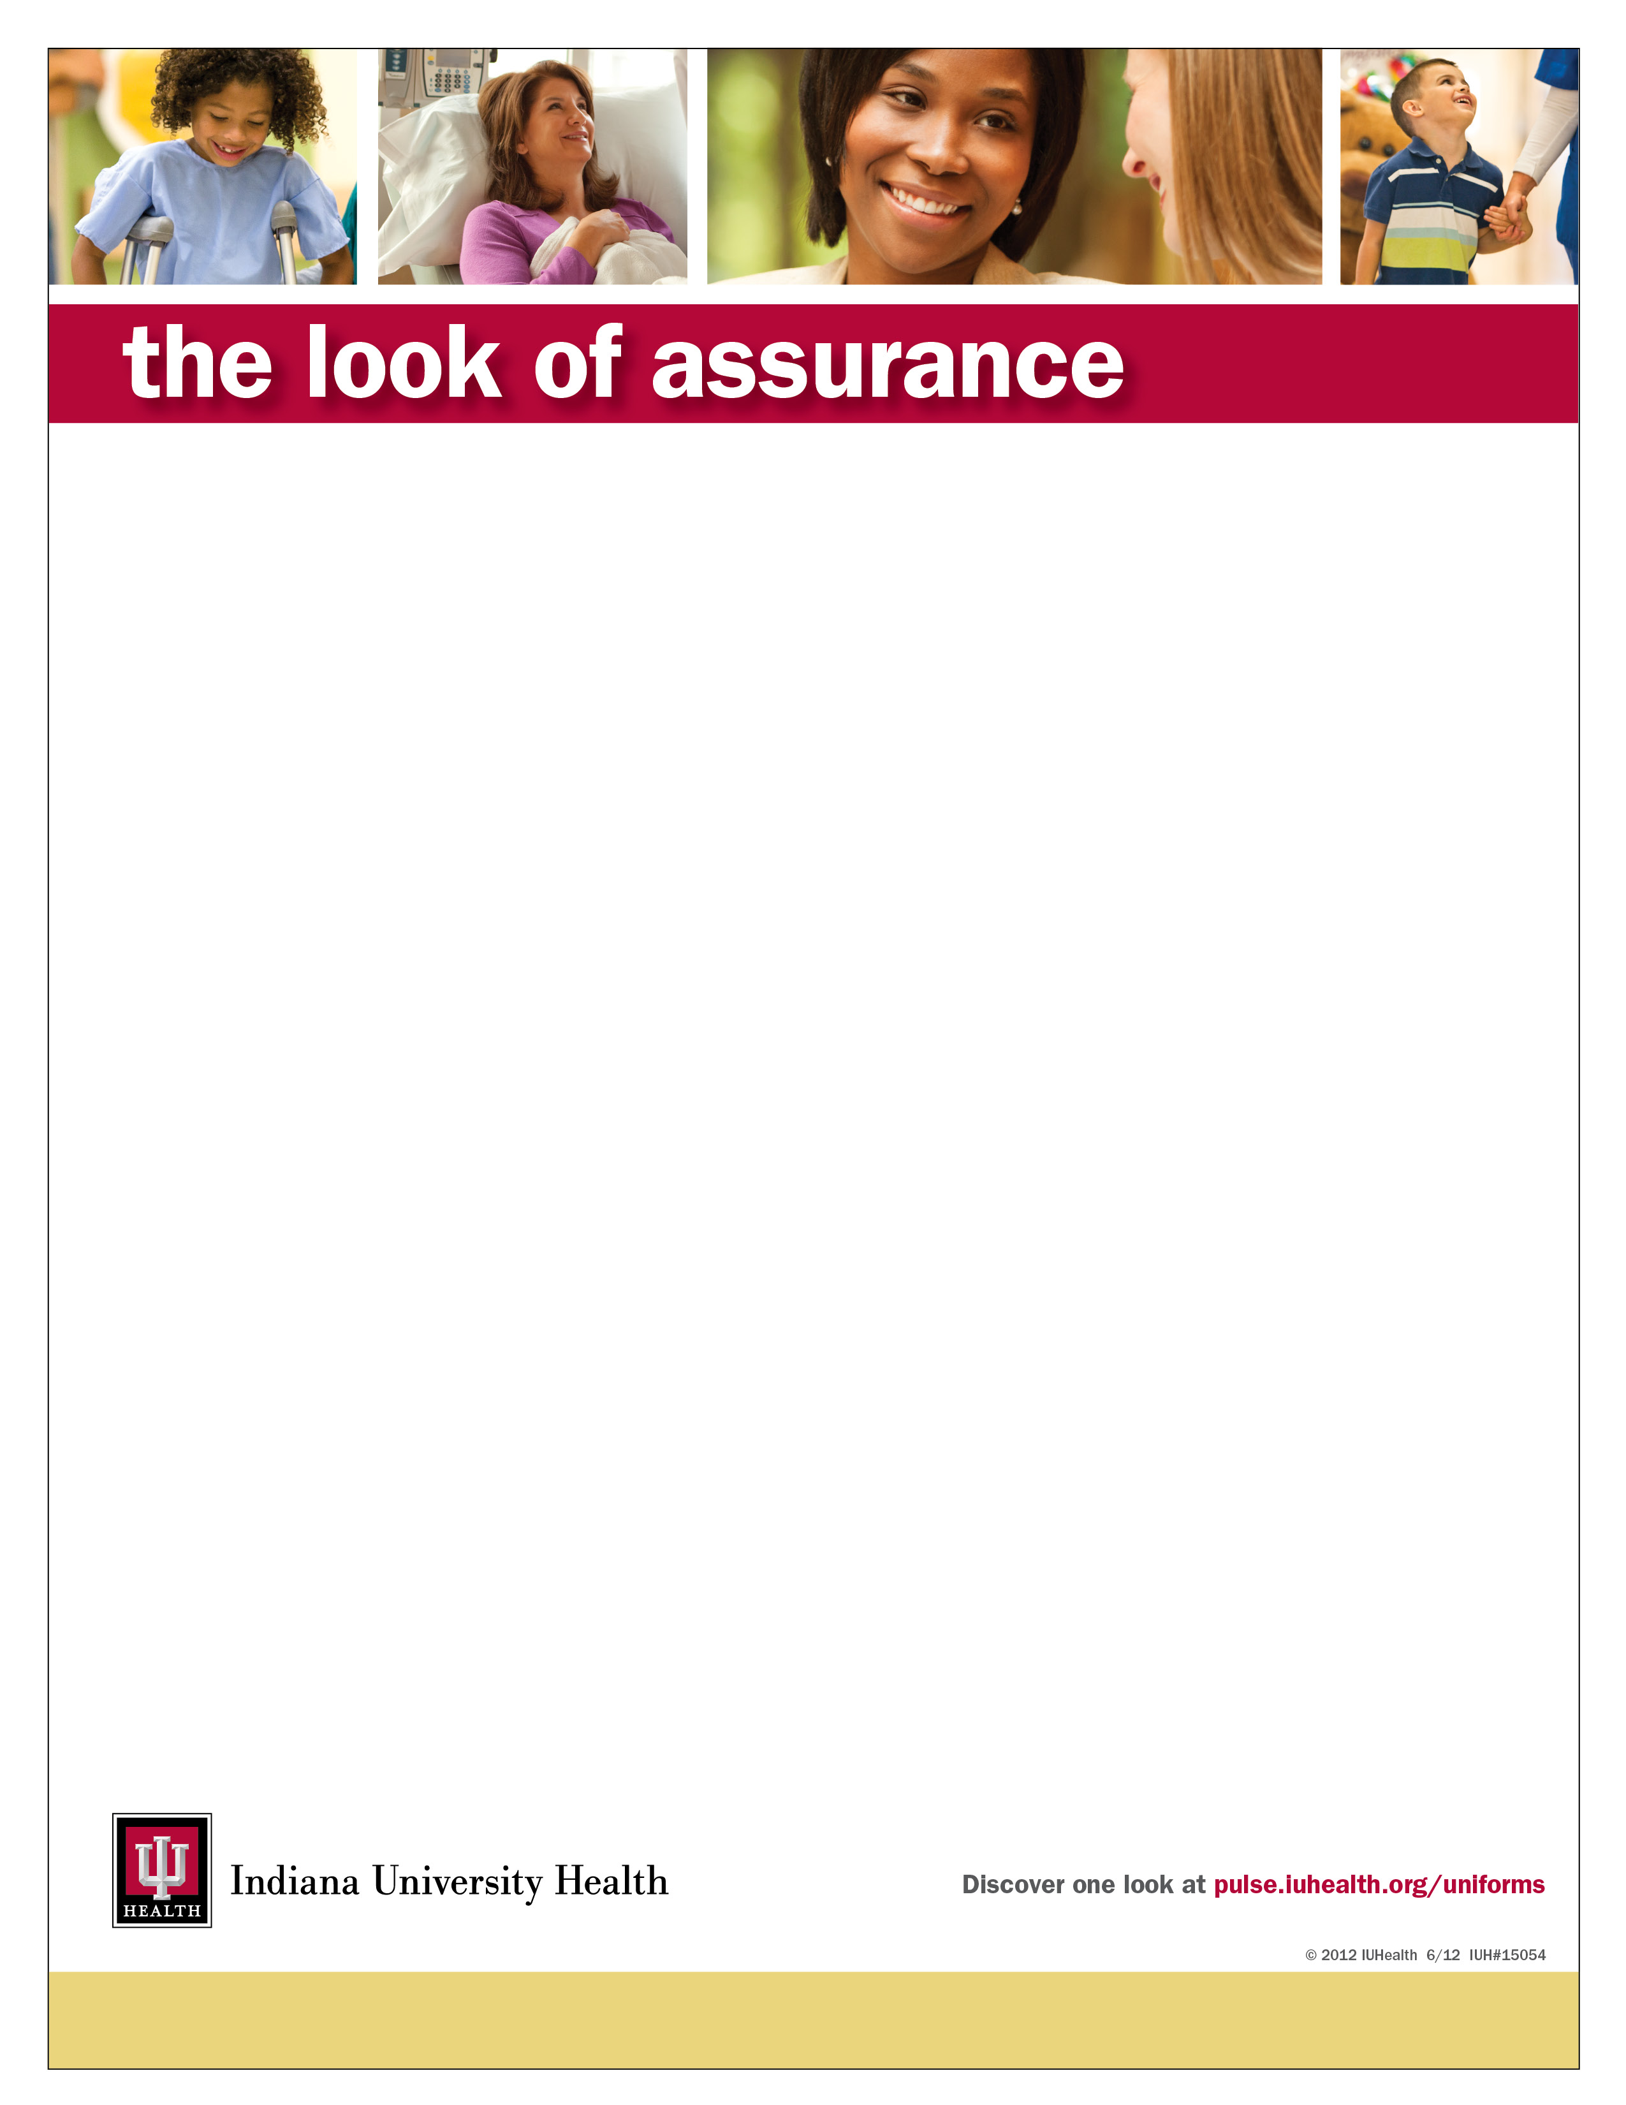Look of Assurance Fitting Room
The Look of Assurance Fitting Room has all uniforms in all sizes. It is very important for team members to utilize the fitting room to try on their uniforms to ensure a proper fit and size. The cost of returns and exchanges is the responsibility of the team member, so we encourage you to visit the Look of Assurance Fitting Room.

Location:
2110 N. Capitol Avenue
Indianapolis, IN 46202

The store is in a one-story brick building. It is located just north of the corner of 21st and Capitol, right beside the Shell Gas Station, in the same building as the Dialysis Center. Look for the number “2110” on the door.

Look of Assurance Fitting Room Hours

Monday, Tuesday, Wednesday of IU Health Essentials Week

4:30 pm – 6:00 pm

2013 IU Health Essentials Schedule

Month | Days | Month | Days
January | 2, 3, 4, 14, 15, 16, 28, 29, 30 | July | 1, 2, 3, 15, 16, 17, 29, 30, 31
February | 11, 12, 13, 25, 26, 27 | August | 12, 13, 14, 26, 27, 28
March | 11, 12, 13, 25, 26, 27 | September | 9, 10, 11, 23, 24, 25
April | 8, 9, 10, 22, 23, 24 | October | 7, 8, 9, 21, 22, 23
May | 6, 7, 8, 20, 21, 22 | November | 4, 5, 6, 18, 19, 20
June | 3, 4, 5, 17, 18, 19 | December | 2, 3, 4, 16, 17, 18

For more information, contact Steve Daudy in Supply Chain Operations at 317-962-9362 or sdaudy@iuhealth.org.

